
a
Company
Logotype

Cone Beam Computed Tomography- Report



Porur Dental X-rays & CBCT

Patient Name : Mr. Ravi Shekhar | Date of Report : 04.05.2024
Age/ Gender : 67 years/ Male | Region of Interest : CBCT Sectional Maxilla
Referring doctor: Dr. Subramoniam | Indication : Implant assessment
Clinical Notes: Nil
PATIENT INFORMATION

CBCT- Sectional Maxilla provided
CBCT – IMAGE DETAILS

RADIOGRAPHIC INTERPRETATION

- Completely missing crown and root portion in relation to 15, 16, 17, 18.
- The maxillary alveolar ridge is present with normal trabecular pattern.
- The teeth 13, 14 are present with hyperdense restorative material within the pulp canal extending upto the apical third.
- The tooth 14 is present with a diffuse periapical hypodensity measuring 5.41 x 6.11 x 5.33 mm in dimension with irregular borders.

IMPLANT ASSESSMENT

 | 13 region | 14 region
Sub-Crestal | 11.25 | 10.72
Mid- Crestal | 11.54 | 10.73
Distance between the alveolar ridge and Floor of the Nasal cavity (in mm) | 16.85 | 20.32

 | 15 region | 16 region | 17 region
Sub-Crestal (in mm) | 7.37 | 10.87 | 10.74
Mid- Crestal (in mm) | 10.82 | 12.76 | 11.76
Distance between the alveolar ridge and floor of the maxillary sinus (in mm) | 9.18 | 5.94 | 5.52

RADIOGRAPHIC IMPRESSION

- Partially edentulous maxillary arch.
- Root canal treated 13, 14
- Residual periapical pathology in relation to 14.

Kindly correlate with clinical findings


IMAGES FOR REFERENCE

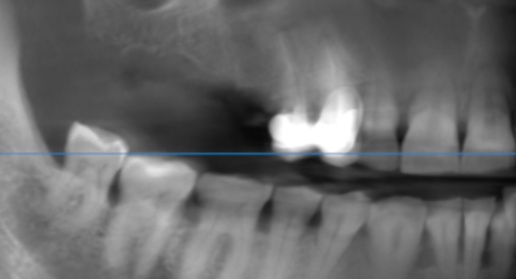

3-DIMENSIONAL VIEW

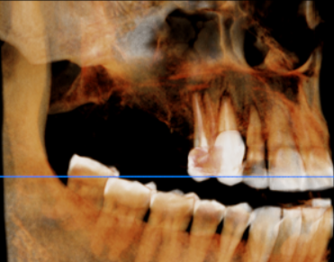

CROSS SECTIONAL VIEW

13 region | 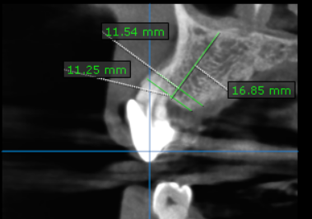
14 region | 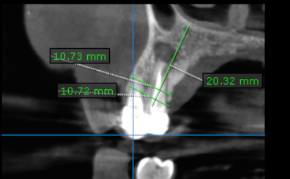
15 region | 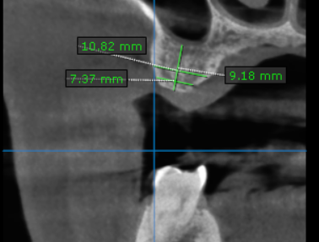
16 region | 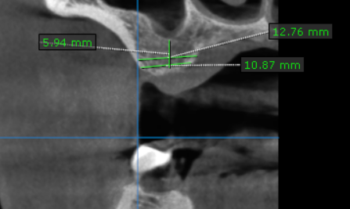
17 region | 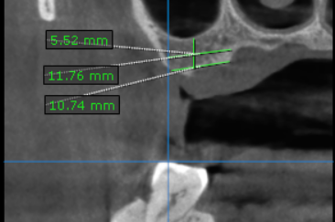

**** End of report ****

